Student's name: Case study #
Instructor's name:
Client's first name or code: Age: Sex:
Occupation:
Sports/hobbies/activities:

Previous operations/accidents/illnesses. Record dates and details:

Pain patterns/restricted movements:

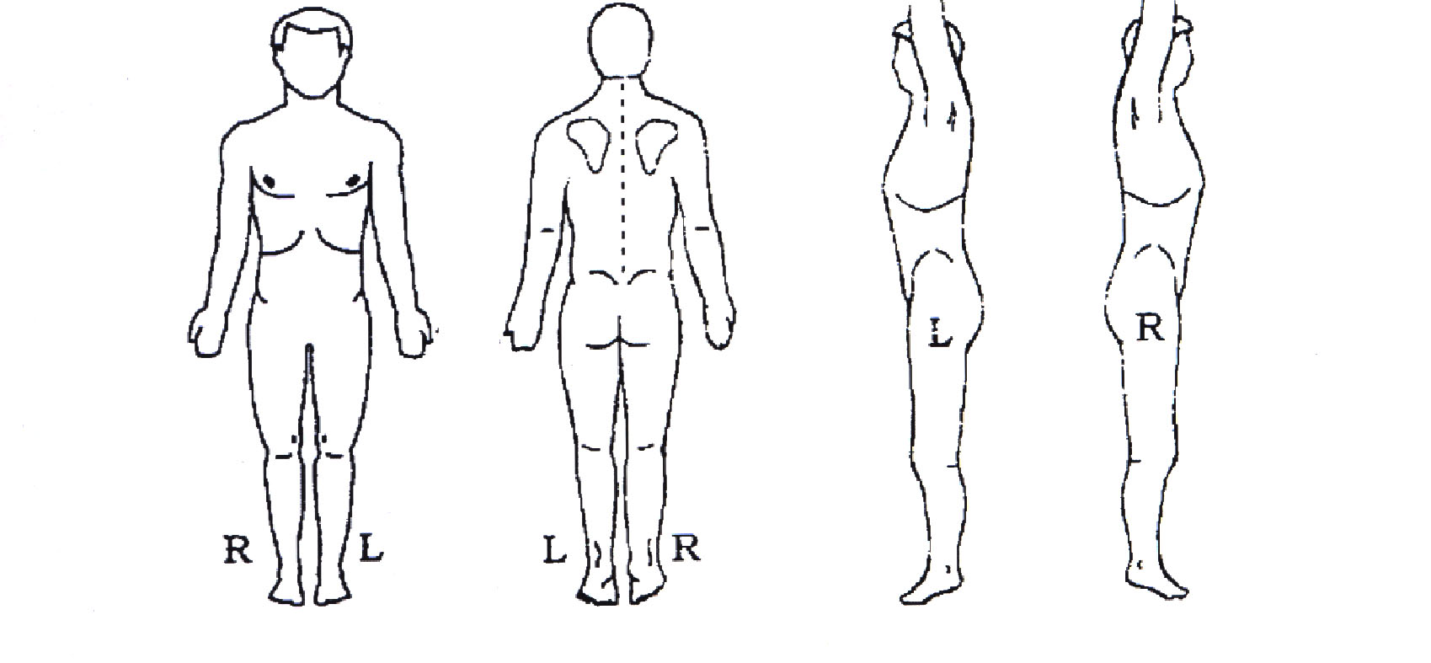

Presenting condition(s):

Prior treatment for presenting condition(s):

Other relevant comments:

SESSION 1 - Date:

Your assessments:

Procedures used (include reasons for your choices):

Comments/observations:

Recommendations/exercises:

SESSION 2 - Date:

Client's comments: progress/changes observed since last session:

Your assessments:

Procedures used (include reasons for your choices):

Comments/observations:

Recommendations/exercises:

SESSION 3 - Date:

Client's comments: progress/changes observed since last session:

Your assessments:

Procedures used (include reasons for your choices):

Comments/observations:

Recommendations/exercises:

AFTER THE LAST SESSION WITH THIS CLIENT:

Your assessment of client's progress:

What discoveries if any did you make through working with this client?

